GLOBAL SUPPLY CHAIN MANAGEMENT

[Author] [Institution]

Abstract

Supply chain activities are having significant impact on the business functions of organization that looking to expand business in global marketplace. The understanding and planning of supply chain elements is essential for organizations to encourage the business. The report will analyze and plan the various aspects for Textile Company that is having manufacturing in India and importing the raw material from countries like China, Nepal and Pakistan. The supply chain planning will help management to manage the other function and maintain the smooth flow of operations to achieve the goals and objectives.

Table of Contents
Introduction 6
Concept of supply chain management 6
Demand forecasting and supply chain planning 8
Production management 10
Procurement and inventory management 12
Sustainable supply chain 14
SCOR model 15
Global supply chain management strategy 16
Global sourcing, distribution and logistics 18
Conclusion 20
References 21
Appendix 1: 25
Appendix 2: 26

List of table
Table 1: Inventory approaches 14

List of figures

Figure 1: Supply chain concept 7
Figure 2: Demand forecasting elements 10
Figure 3: Just In Time approach 12
Figure 4: SCOR model 16
Figure 5: Supply chain in clothing industry 25
Figure 6: Benefits of supply chain 26

Introduction

Supply chain management is the broad range of activities that involve planning, controlling and implementation of goods and services flow. This process starts with a collection of raw material and distribution of finished goods and services to the end users in cost-effective manners. It is a structured process that helps to manage the demand and increases the satisfaction level of customers by improving and availability of products and services in the target market. The supply chain management plays the critical role in maintaining the sustainability of the market and proper management of distribution channel. The current report will develop a plan for managing the supply chain activities for a textile company from India which exporting the raw material from China, Philippines, Nepal and Pakistan. The report will discuss the key concept of the supply chain, a process of demand forecasting, production and procurement management. Moreover, it will provide information about SCOR model of the supply chain to develop the plan for global supply chain management of the organization in the local and international market.

Concept of supply chain management

Supply chain management concept refers to the planning of products and services according to demand forecasting, procurement and logistics expertise to move the products and services to the customers. There are different types of models and principles used by the textile organization for managing the supply chain activities and measuring the performance. In the beginning, the textile organization management needs to define the segment of customers as per the need of the target group of customer that will help to select and better strategy for the supply chain (Mamic, 2017). The customized supply chain network will support to ensure the proper management of distribution services and improve the level of profit. The significant issues that

an organization face in supply chain management are cost control, planning and risk management, relationship with the supplier and partner as well the fast-changing needs of a market (Christopher, 2016). In the era of globalization, the supply chain management becomes more complex and broad that creates issues for the organization to meet the requirements of customers.
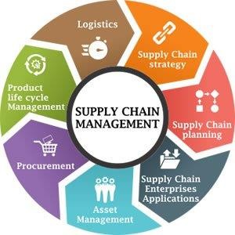

Figure 1: Supply chain concept (Source: Supply chain concept, 2018)
There are majorly five types of models used by the organization for managing the supply chain in the global context such as efficient, fast, continuous flow, agile and flexible model. By using these models, the organization can improve or maintain the effective supply chain services from collection of raw material to distribution of finished goods and services. The efficient model is used for highly competitive markets and based on the cost of products (Tramarico and et al., 2017). The fast model of the supply chain is concerned with manufacturing of products according to demand of the products according to trends of the market. Moreover, the

continuous-flow model is used to maintain the high demand stability. This model is suited for mature industries with little variation in the customer demand profile. The agile model is ideal for manufacturing organizations like textile that design and develop the products according to of needs of customers. The agile model uses make-to-order decoupling points that involve manufacturing of products after receiving the order from the customer (Bag and et al., 2017). The flexible model is used for high demand products and services that require the high adaptability with capabilities to reconfigure internal process to meet the customer’s issues. The top management of textile company could use one of these model according to geographical conditions and
The strategies that used for managing supply chain activities involve Demand-driven planning, Adaptive and agile supply, Optimize product design and Sustainability into supply chain operations. The organization could use one of these strategies for maintaining supply chain operations in India and overseas market to maintain the effective distribution of clothing products (Monczka and et al., 2015). To gain the competitive advantages, the organization above models and strategies this will help to manage the supply chain functions and effective utilization of a global marketplace.

Demand forecasting and supply chain planning

Demand forecasting is an essential term that used for managing the manufacturing and distribution activities for an organization. The major components of demand forecasting are demand forecasting accuracy, lead-time forecasting, order-cycle optimization and order-validity assurance. The textile organization that is going to start the business in India and other overseas location need to consider the forecasting activities that will help to define the capacity of the business plant for manufacturing to meet the demand (Mangan and et al., 2016). The proper

estimation of demand will be beneficial for an organization to make the order to raw material from overseas and maintain the inventory to design the clothing range as per the demand.
Moreover, the textile organization could use methods for demand forecasting that involve a survey of buyer’s intention, collective options, trend projection, executive judgment and economic interdictors as well the expert opinion. For textile organization from India, the expert opinion method will be beneficial as the textile industry is wide and organization is looking to expand the business in European countries too. The major advantages of expert opinion method for forecasting are high accuracy, stability, economic and help to analyze the data speedily. Apart from that, some issues that organization needs to encounter while using this method of forecasting are lack of facts for particular area and segmentation of the market (Busse and et al., 2017). The components of aggregate planning and sales planning operation are useful for production, inventory and customer leads for managing the demand of supply across the agreed horizon.
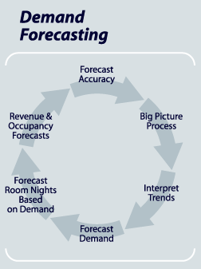

Figure 2: Demand forecasting elements (Source: Demand forecasting elements, 2018)
The use of technology for managing the aggregate planning and sales operation, the textile organization need to make concern over the trials and errors for managing the resources. The process of aggregate planning will focus on demand forecasting for the relevant period for the clothing business (Bag and et al., 2017). The major elements of aggregate planning for the textile organization are capacity planning, sub-contracting and outsourcing of goods. In addition to this, the proper management of workforce will help to improve the inventory functions and production efficiency. For effective utilization of aggregate planning strategy, the management of textile could use the level strategy. According to this strategy, the management of organization will able to increase the decrease the level of production as per the demand forecasting.

Production management

For managing the production of textile products in India and distribution in overseas locations the management could use various methods like Make to Order, Make to Stock and JIT system. The strategies that textile organization could use for managing the production in India are Make to Order and Just-In-Time. Make to Order strategy refers to customized purchase for consumers considering the specification (Rajeev and et al., 2017). The company will maintain production functions according to the order of customers and analysis of purchase activities. In this process, the manufacturing will start after the confirmation of customer order and understanding the specific needs and requirements. This strategy is also known as pull-type production to manage resources according to demand and planning of the operations (Brandenburg and et al., 2014). This kind of process will help organization at the initial stage for understanding the demand and maintain the supply accordingly.

Another strategy for production management that organization could use is Just-In-Time. According to this strategy of production management, the textile organization will be able to increase the efficiency and decrease the waste. In this process, the management will export the raw material as per the needs of production that will support to overcome the inventory cost. Moreover, to utilize the opportunities of the market and maintain the Just-In-Time process organization needs to improve the forecasting of the local and international target market. Moreover, to improve the effectiveness of the strategy, the textile company needs to maintain constructive relationships with global suppliers and control over the distribution of products evaluating the competition level (Dubey and et al., 2017). The key aspect of global supply chain management in retail business is Just-In-Time production. The fashion industry is delivering the trendy products in clothing in different tastes through effective control and integrated process using the Just-In-Time process. The company requires to keeps a significant amount of production in-house and ensures that the manufacturing unites reserves 85% of their capacity for in-season adjustment. This kind of process in production will help the organization to maintain the flexibility in amount, frequency and variety of new products launching in the global market. In order to maintain the best process for production, the textile organization could use the JIT strategy (Waters, and Rinsler, 2014). To implement this strategy management requires analyzing and collecting the data for forecasting.

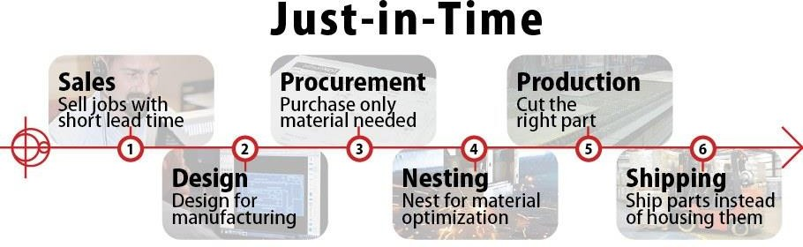

Figure 3: Just In Time approach (Source: Just In Time Approach, 2018)

Procurement and inventory management

The process of procurement refers to streamline the purchasing to ensure offering the best price for goods and services. The consideration of most reputed vendors will be beneficial for the organization to minimize the order delay and mistakes. For the textile organization that looking to offer clothing products and services in India and international market has to consider the following procurement process:
- Identification of goods and services: The textile organization need to identify the needs of goods and services for manufacturing of high-quality products. The company will import silk, cotton and other products from China, Pakistan and Nepal (Brindley, 2017). For purchasing, management will consider the cost of managing the supply.
- Selection of vendor: It is essential for the organization to analyze the vendors and select the best ones for India and overseas market. For that, management needs to evaluate the values of the vendor to maintaining the quality of goods

and services. The comparison of price and quality will be beneficial for an organization (Beske, and Seuring, 2014).
- Submit purchase request: in the stage of procurement management the financial department of an organization will analyze and control the purchase of goods and services from local and overseas vendors. The purchasing department of the organization will send the request for buying the raw material and getting the approval for top management.
- Create purchase order: After submitting the purchase request, the management of Textile Company will generate the order by using the electronic purchase system. The purchase order will involve legal documents for managing activities.
- Receive invoice: In this stage, the management will receive the invoice for order and confirm the order of purchase from specific suppliers. The beginning a limited amount will be offered to the vendor according to the order of goods and services.
- Pay for services: As the order receives and confirm, the organization needs to deliver the payment to the supplier (Brindley, 2017).
- Record for audit: This is the final stage of procurement cycle, in this stage the purchasing department of an organization will keep the record and conduct the audit offered the budget.
The cost of purchasing for raw material for the organization will be based on the forecasting as the demand for products and services is high than management will increase the budget for procurement. In addition to this, inventory management refers to the determination of

the health of the supply chain management by analyzing the impact on the health of balance sheet (Schorsch and et al., 2017). The approaches for inventory management involve input for raw material, consumable required for processing, maintenance and packing of material.
Table 1: Inventory approaches

Input | Process | Output
Raw material | Manufacturing | Finished goods
Consumable required | Design, cutting, sewing and  QC | Distribution of products
Maintenance | Identification of production  waste | Finish goods and transit

Sustainable supply chain

For the fashion industry organization that is going to open a new business, it is essential to maintain the sustainability of supply chain and overall business functions to improve the brand value. To manage the operation of supply chain management at the global level, it will be important for a textile organization to implement the Green supply chain management process. The sustainable supply chain management is having the impact on the level of environmental, social and economic viability of the organization. In the current scenario, the governments of nations are strict about waste management and offering the guideline for manufacturing organizations to maintain the sustainable approach (Rushton and et al., 204). It is essential for an organization to follow the rules and regulations for maintaining the sustainability in procurement management and planning of the issues that could influence the supply chain. The top management is concern about the green supply of products and services as well analyzing the production level by focusing on manufacturing functions.

The management of textile organization needs to take responsibility for the betterment of the environment and follow up of rules and regulations for managing waste, recycling of it and control over the emission of CO2. This kind of practices will support organization to maintain the sustainability of supply chain operation and support to achieve the goals and objectives in the global marketplace. The theories that organization could use for managing the sustainable supply chain involve the macro theory on resources based review (Beske, and Seuring, 2017). According to this theory, the management will try to maintain the positive relationship with staff and supplier to maintain the resources more efficient manners. The market research and planning of resources is beneficial for maintaining the streamline operations for supply chain management and effective utilization of opportunities.

SCOR model

The management of Textile Company could use this model for managing the supply chain in the global marketplace. The Supply Chain Operation Reference model is beneficial for the organization for analyzing and meeting the demand of the customers and by delivering the products and services on time. By implementing this model of the supply chain, the management will focus on four major aspects such as plan, source, make and deliver (Grant and et al., 2017). According to this model, planning of textile organization will be based on demand forecasting which will be beneficial for purchasing of raw material. The effective communication with supplier and designer will also support to plan the operational activities. In addition to this, the sourcing of raw material will be managed according to order (Christopher, 2016). The management will analyze the performance of global and local supplier for developing the network for the achievement of goals.

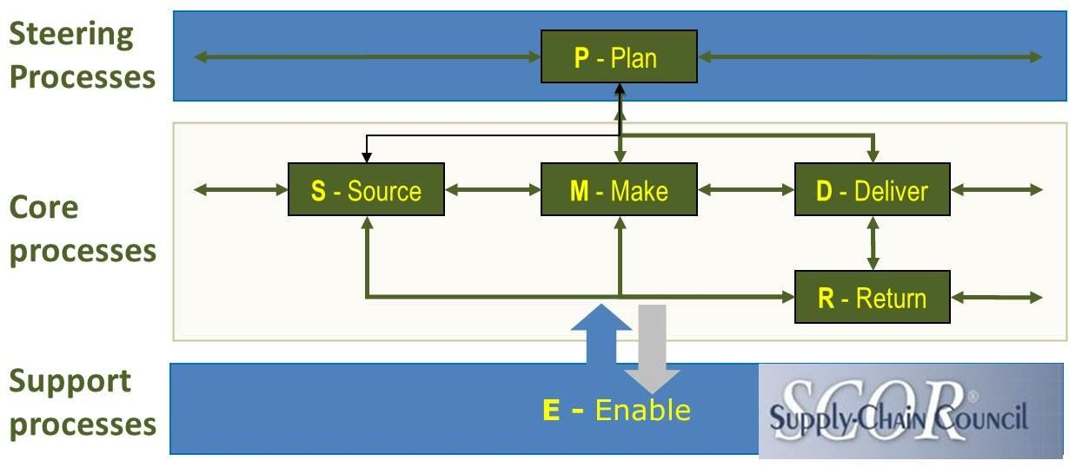

Figure 4: SCOR model (Source: SCOR model, 2018)
For better production management, the organization needs to design functions in line that will help to minimize the time and cost of manufacturing. This kind of process will help to improve the level of efficiency and maintain the Just-In-Time operation for inventory. The implementation of SCOR model will also support in the delivery of products by focusing on orders and developing the network for distribution in a local market of India and international locations. For that purpose, the organization needs to find the warehouses at the overseas location to maintain the supply chain process (Fahimnia and et al., 2015). At the current level, the company needs to focus on the capacity of production and demand to plan the distribution level and supply of products.

Global supply chain management strategy

The organization is looking for managing the business at overseas location and planning of the function to meet the demand for high-quality clothing products at international level. The global supply chain strategy for the textile organization from India will involve consideration of

upstream functions that will involve access to lower priced goods, high-quality goods and use of online technology for managing the delivery and improvement in the reliability. Apart from that, the management could also analyze the downstream functions for managing the international supply chain activities (Usui and et al., 2017). The proper consideration of demand of clothing products in specific locations at initial stage will support for the setting the dimensions for global supply chain and variable exchange in the cost of transportation, raw material, lead time and inventory of product and services. However, the organization currently has good infrastructure in India for the production but to maintain the supply chain operations in global context company needs to develop the high skill team and supplier activities (Govindan and et al., 2014). The major challenges in global supply chain activities are variability and uncertainty in currency exchange rates, economic and political instability and changes in the regulatory environment.
The specific challenges in international supply chain management for global supply chain operation involve manufacturing and distribution of product and services. To manage the transportation in international locations, it is essential to develop the powerful system for communication with supplier and retailers. The cost of logistics and warehouse will influence the overall financial activities of the new organization to establish the business in overseas locations. To manage the supply chain functions in the location like China and Nepal, the organization could contact the suppliers of raw material to help in finding the distribution network (Jacobs and et al., 2014). The local suppliers will able to provide the cost-effective functions for managing supply chain activities and overcome the consequences of safety and inventory.
The network of global supply chain management:

The global supply chain management for the textile organization from India will require the support of network to develop the proper flow of products and services to meet the

organizational objectives. The design of supply chain network will involve objectives of the textile organization, development of project scope, analysis of the local condition of business and determination of tools that will be used for managing the supply chain operation (Paulraj and et al., 2017). The design function of global supply chain activities will involve the analysis of low- cost labor, language barriers and cultural differences to maintain the good relationship with the supplier. Now, to establish the global supply chain activities in textile business the management could focus on inventory, key needs of customers and supplier from the international market and evaluation of the business process of local organization (Mangan and et al., 2016). In addition to this use of performance metrics and customer services requirements will be useful for the textile organization to manage the global supply network.
The major risks in global supply chain network involve extreme weather conditions, government issues, lack of skilled labor, and cost of currency. For example, the textile organization is looking for expanding business in the European nation in the near future. To meet the goals of the global supply chain, the management requires developing the plan for managing the identified risk as well compliance with the government laws and regulation. The analysis through quantities and qualitative methods of the market will support organization to manage the risks in the global supply chain operation and meet the objectives more professional manners (Monczka and et al., 2015). The risk of lacking in skilled labor can be managed through offering the training and knowledge about decision-making aspects.

Global sourcing, distribution and logistics

Global sourcing is the practice of managing the function of budget planning and distribution in the international market. The textile organization is looking to expand business in the global market as management is targeting the European countries for selling of finished

goods and services. Some factors affect the business function of the organization in sourcing of raw material. The major factors that are having the significant impact on sourcing function involve the total landed cost, quality of products and services. In the current scenario, the organization is not having any logistic services and potential to manage the supply chain function in overseas locations (Pagell, and Shevchenko, 2014). The high dependency on global sourcing agents can influence the quality of products and services as well affect the profit margin. In addition to this, the factors that were affecting sourcing for global supply chain functions requires the consideration of trade regulation and communication with the suppliers. The management of Textile Company will be responsible for developing the plan for maintaining proper distribution and relation with the overseas supplier.
The major costing factors that need to be considered for maintaining sourcing at the global level will involve planning of location, transportation facilities, inventory cost and distribution functions to meet the objectives. In spite of that, government and political condition are having the major influence on global sourcing. For example, the Chinese government does not allow the overseas organization to improve the business by using their sources utilizing the network (Wang and et al., 2016). The rules and regulation for taxes and use of technology are also hard that shape the decisions of organizations to start sourcing from Chain to meet the supply chain objectives.
The global distribution strategy that can be used by an organization like the textile company from India involves working with distributors and online export. The strategy of working with distributors is having a significant impact on the export management of the organization to arrange the process of product distribution and shipping of products and services. The approach of working with distributors will support to improve the distribution of clothing

products in foreign areas and the establishment of the company in overseas locations. The local distributers will support the handling of products and marketing. Apart from that online distribution method is also helpful for new organization to understand and manage distribution in the global market (Wisner and et al., 2014). The online extension of distribution functions will be useful for an organization to overcome the cost of distribution.
The logistics management covers the physical movement of products and services considering the raw material to finished goods to the end users. The key aspects of global logistics management for Textile Company will require concern over, production input that demands on market size and demand of the services in the global market (Dubey and et al., 2017). The transportation and customs clearance is essential for managing logistics services in the international business.

Conclusion

From the above study, it can be considered that supply chain is one of the major elements of the business process of an organization. To gain the competitive advantage and planning of the international presence, the major concern of any organization would be on supply chain function. The report has provided the brief discussion of supply chain concept, demand forecasting and production management for the textile organization from India that exporting raw material from China, Nepal and Pakistan. Moreover, the report has planned the strategy for managing supply by using the SCOR model and resource-based view theory for global expansion of business and planning of global supply chain activities.

References

Bag, S., Anand, N., & Pandey, K. K. (2017). Green Supply Chain Management Model for Sustainable Manufacturing Practices. In Green Supply Chain Management for Sustainable Business Practice (pp. 153-189). IGI Global.
Bag, S., Anand, N., & Pandey, K. K. (2017). Green Supply Chain Management Model for Sustainable Manufacturing Practices. In Green Supply Chain Management for Sustainable Business Practice (pp. 153-189). IGI Global.
Beske, P. & Seuring, S., (2017). Putting sustainability into supply chain management. Supply Chain Management: an international journal, 19(3), pp.322-331.
Beske, P., & Seuring, S. (2014). Putting sustainability into supply chain management. Supply Chain Management: an international journal, 19(3), 322-331.
Brandenburg, M., Govindan, K., Sarkis, J., & Seuring, S. (2014). Quantitative models for sustainable supply chain management: Developments and directions. European Journal of Operational Research, 233(2), 299-312.
Brindley, C. (Ed.). (2017). Supply chain risk. Taylor & Francis.

Busse, C., Meinlschmidt, J., & Foerstl, K. (2017). Managing information processing needs in global supply chains: A prerequisite to sustainable supply chain management. Journal of Supply Chain Management, 53(1), 87-113.
Christopher, M. (2016). Logistics & supply chain management. Pearson UK.

Demand forecasting elements, 2018. Retrieved from: < http://myalldocuments.blogspot.in/2013/07/short-notes-on-demand-forecasting-types.html
> retrieved on 30 April 2018

Dubey, R., Gunasekaran, A., Childe, S. J., Papadopoulos, T., & Fosso Wamba, S. (2017). World class sustainable supply chain management: critical review and further research directions. The International Journal of Logistics Management, 28(2), 332-362.
Dubey, R., Gunasekaran, A., Papadopoulos, T., Childe, S. J., Shibin, K. T., & Wamba, S. F. (2017). Sustainable supply chain management: framework and further research directions. Journal of Cleaner Production, 142, 1119-1130.
Fahimnia, B., Sarkis, J. & Davarzani, H., (2015). Green supply chain management: A review and bibliometric analysis. International Journal of Production Economics, 162, pp.101-114.
Govindan, K., Kaliyan, M., Kannan, D. & Haq, A.N., (2014). Barriers analysis for green supply chain management implementation in Indian industries using analytic hierarchy process. International Journal of Production Economics, 147, pp.555-568.
Grant, D. B., Wong, C. Y., & Trautrims, A. (2017). Sustainable logistics and supply chain management: principles and practices for sustainable operations and management. Kogan Page Publishers.
Jacobs, F.R., Chase, R.B. & Lummus, R.R., (2014). Operations and supply chain management (pp. 533-535). New York, NY: McGraw-Hill/Irwin.
Just In Time approach, 2018. Retrieved from: < http://www.latestquality.com/advantages-just- time-manufacturing/> retrieved on 30 April 2018
Mamic, I. (2017). Implementing codes of conduct: How businesses manage social performance in global supply chains. Routledge.
Mangan, J., Lalwani, C. & Lalwani, C.L., (2016). Global logistics and supply chain management.

John Wiley & Sons.

Monczka, R. M., Handfield, R. B., Giunipero, L. C., & Patterson, J. L. (2015). Purchasing and supply chain management. Cengage Learning.
Pagell, M. & Shevchenko, A., (2014). Why research in sustainable supply chain management should have no future. Journal of supply chain management, 50(1), pp.44-55.
Paulraj, A., Chen, I. J., & Blome, C. (2017). Motives and performance outcomes of sustainable supply chain management practices: A multi-theoretical perspective. Journal of Business Ethics, 145(2), 239-258.
Rajeev, A., Pati, R. K., Padhi, S. S., & Govindan, K. (2017). Evolution of sustainability in supply chain management: A literature review. Journal of Cleaner Production, 162, 299-314.
Rushton, A., Croucher, P., & Baker, P. (2014). The handbook of logistics and distribution management: Understanding the supply chain. Kogan Page Publishers.
Schorsch, T., Wallenburg, C. M., & Wieland, A. (2017). The human factor in SCM: Introducing a meta-theory of behavioral supply chain management. International Journal of Physical Distribution & Logistics Management, 47(4), 238-262.
SCOR model, 2018. Retrieved from: < https://scm.ncsu.edu/scm-articles/article/the-scor-model- for-supply-chain-strategic-decisions> retrieved on 30 April 2018
Supply chain benefits, 2018. Retrieved from: < http://barokah.goodlook.site/supply-chain- management-benefits/> retrieved on 30 April 2018
Supply chain concept, 2018. Retrieved from: < https://www.nevprobusinesssolutions.com/supply-chain-management/> retrieved on 30 April 2018

Supply chain in clothing industry, 2018. Retrieved from: < http://www.fibre2fashion.com/industry-article/4274/enhanced-apparel-chain- configurations-for-enhancing-profits?page=1>retrieved on 30 April 2018
Tramarico, C. L., Salomon, V. A. P., & Marins, F. A. S. (2017). Multi-criteria assessment of the benefits of a supply chain management training considering green issues. Journal of Cleaner Production, 142, 249-256.
Usui, T., Kotabe, M., & Murray, J. Y. (2017). A Dynamic Process of Building Global Supply Chain Competence by New Ventures: The Case of Uniqlo. Journal of International Marketing, 25(3), 1-20.
Wang, G., Gunasekaran, A., Ngai, E.W. & Papadopoulos, T., (2016). Big data analytics in logistics and supply chain management: Certain investigations for research and applications. International Journal of Production Economics, 176, pp.98-110.
Waters, D., & Rinsler, S. (2014). Global logistics: New directions in supply chain management.

Kogan Page Publishers.

Wisner, J.D., Tan, K.C. & Leong, G.K., (2014). Principles of supply chain management: A balanced approach. Cengage Learning.

Appendix 1:
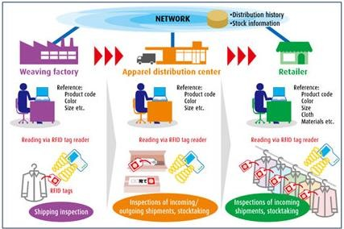
Figure 5: Supply chain in clothing industry (Source: Supply chain in clothing industry, 2018)

Appendix 2:

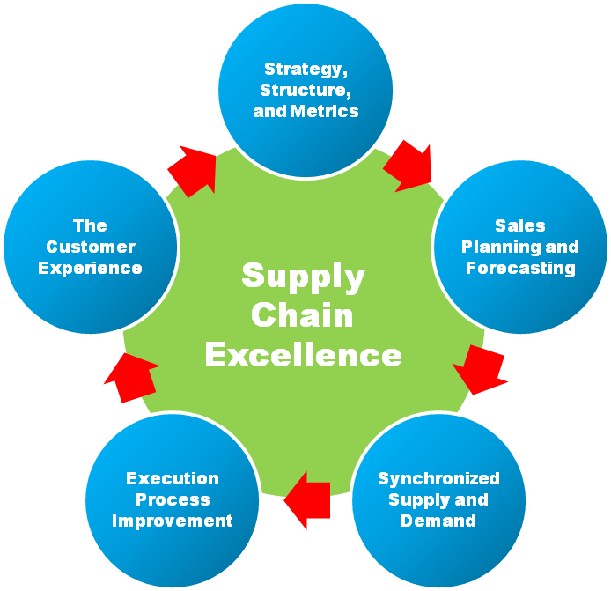
Figure 6: Benefits of supply chain (Source: Benefits of supply chain, 2018)

